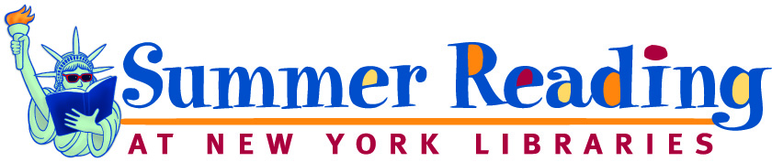

ISLIP MIDDLE SCHOOL
Summer Reading 2018
Students entering Grades 6-8 (Regents Level)

As you head to the beach this summer, don’t forget to pack your towel, your suntan lotion, your sunglasses – and your summer reading book. Why? Summer reading provides an excellent opportunity for students to stay connected to literature, to enhance literacy skills developed during the school year, and to gain knowledge. Plus, it’s fun! According to a variety of studies, students who read frequently not only improve comprehension and become better readers but also increase their vocabularies, strengthen their critical thinking skills, and improve their memories.

Here’s what Islip Middle School students are expected to do:

Sign up for the 2018 Summer Reading Program @ New York Libraries. (You may sign up at any public library. Generally, the program runs from mid-June to mid-August.)

Read at least two books over the summer vacation. You can read any books that you like. If you need help finding an interesting book, speak with your teachers before school ends in June, talk to the librarians, and/or check out the recommended reading lists posted on the New York Summer Reading site. You can also check out the book sites listed on the English Department Page on the Islip School District website.

Bring your Reading Certificate from the Public Library with you on the first day of school. Hand it to your English teacher.

Be prepared to discuss & write about the books you read when you return to school in September.

All information about summer reading can also be found at the following locations:

- Islip School District website
- Middle School main office
- High School main office (for 8th grade students entering 9th grade)
- Reference desk at the Islip Public Library
- Barnes & Noble in Bay Shore

Please Note: Students entering 7 Honors, 8 Honors, & 9 Honors in the fall will receive a different summer reading assignment from their English teachers. (This assignment will also be posted on the school website.)

Enjoy your summer. See you in September!

